|  |  |
| --- | --- |
| DATE | 14 NOVEMBER 2022 |
| TEAM ID | PNT2022TMID48639 |
| PROJECT TITLE | IOT BASED SMART CROP PROTECTION SYSTEM FOR AGRICULTURE |

**IBM CLOUD SERVICES**

**IBM cloud Node-Red:**

**Step 1:**

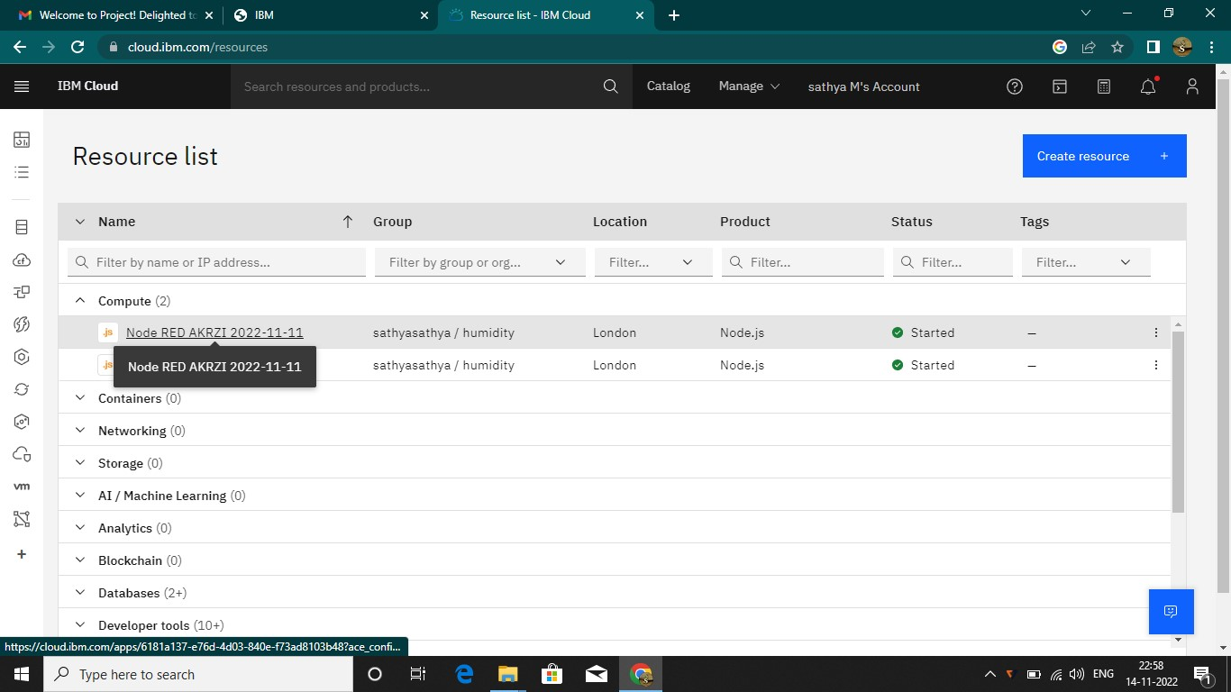

**STEP 2:**

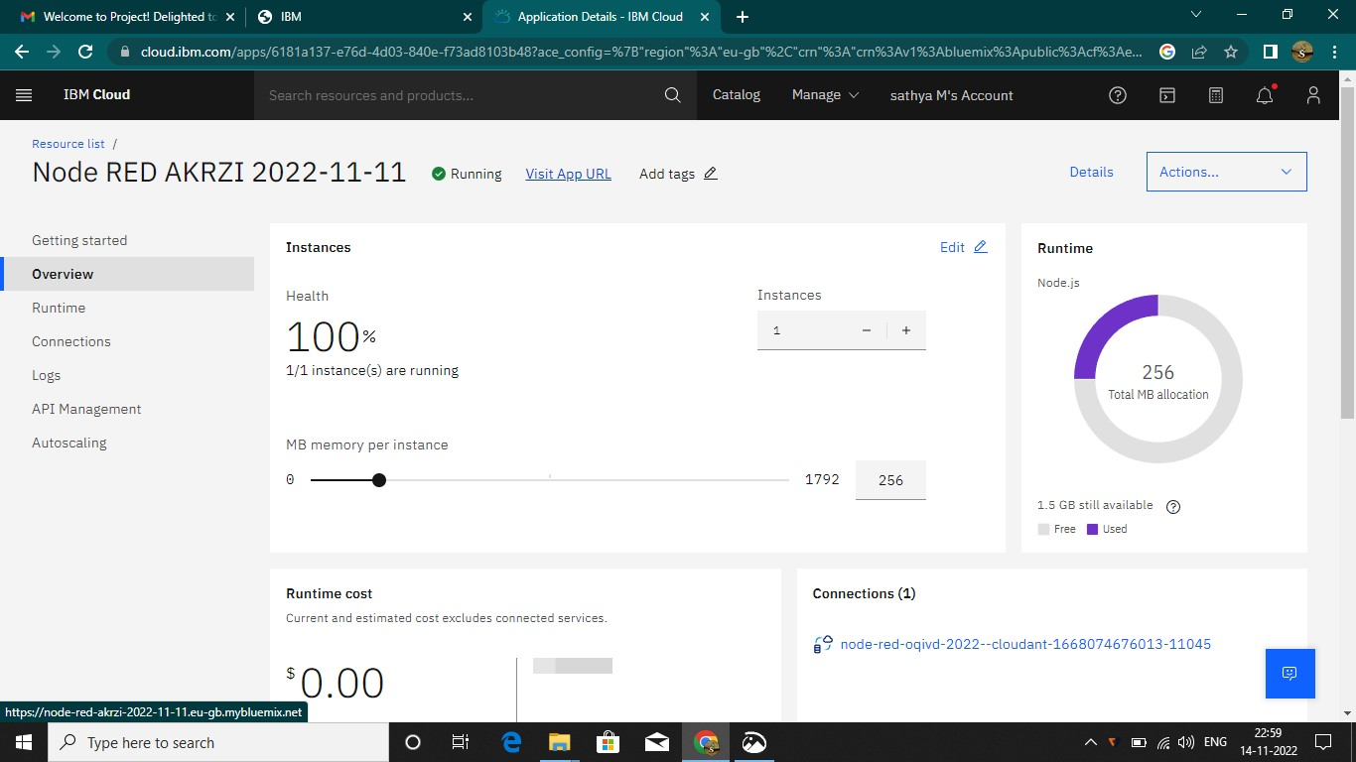

**STEP 3:**

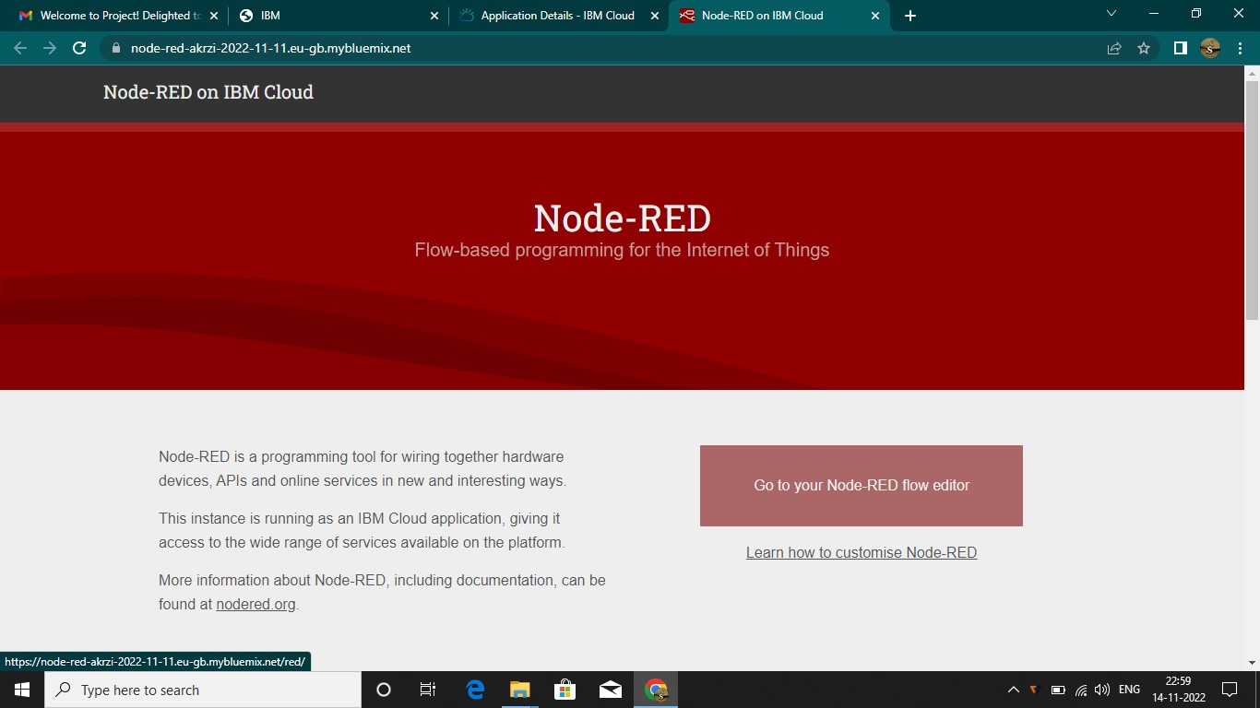

**STEP 4:**

